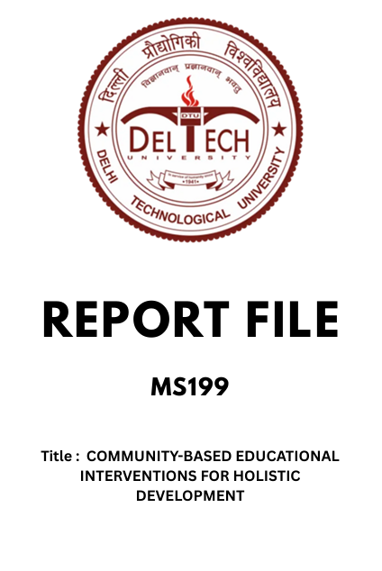
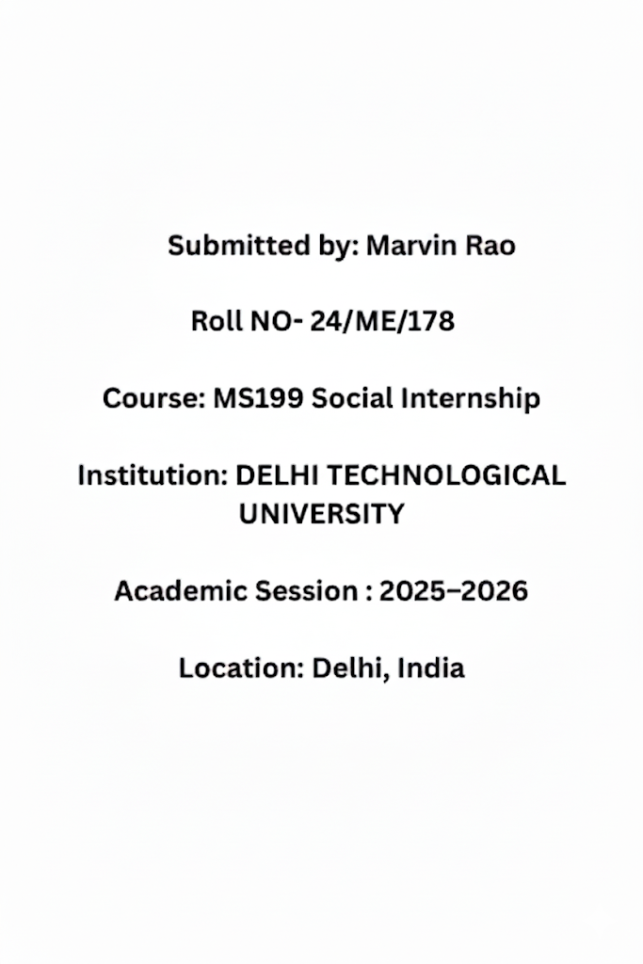

DECLARATION
I, Marvin Rao, Roll No. 24/ME/178, hereby declare that the work presented in this Social Internship Report, titled "Empowering Futures: Social Outreach Activity at VCSGSBV School," is my original work and has not been submitted in part or full to any other course or university for any degree or diploma.
This project was undertaken as a mandatory component of the MS199 Social Internship course curriculum. The activities, observations, and findings detailed herein are a true and accurate reflection of the time spent and tasks performed at VCSGSBV School near Saket Metro Station, where I engaged in teaching and mentoring students.
I understand that any false claim will result in disciplinary action.

Declared by: Marvin Rao Roll No: 24/ME/178
Signature: _________________________
Date: _________________________

CERTIFICATE

This is to certify that the Social Internship Report titled "Empowering Futures: Social Outreach Activity at VCSGSBV School" has been successfully completed by Marvin Rao (Roll No. 24/ME/178) in partial fulfillment of the requirements for the course MS199 Social Internship during the Academic Session 2025-2026.
The student carried out the social outreach activity at VCSGSBV School, near Saket Metro Station, demonstrating dedication in teaching and mentoring students in various subjects.
This report is hereby approved and accepted for evaluation.

Faculty Coordinator's Details:
Name: _________________________
Designation: _________________________
Signature: _________________________
Date: _________________________

ACKNOWLDEGMENT
I wish to express my profound gratitude to everyone who supported me throughout this Social Internship and the preparation of this report.
I am especially thankful to my Faculty Coordinator, [Insert Faculty Coordinator's Name], for their continuous guidance, invaluable insights, and consistent encouragement, which were instrumental in the successful completion of this project.
My sincere thanks go to the Principal and the entire staff of VCSGSBV School, near Saket Metro Station, for allowing me the opportunity to work with their students and for providing a supportive environment for this social outreach activity. The cooperation and enthusiasm of the teachers and students were crucial to my experience.
Finally, I would like to thank my family and friends for their moral support throughout this period.
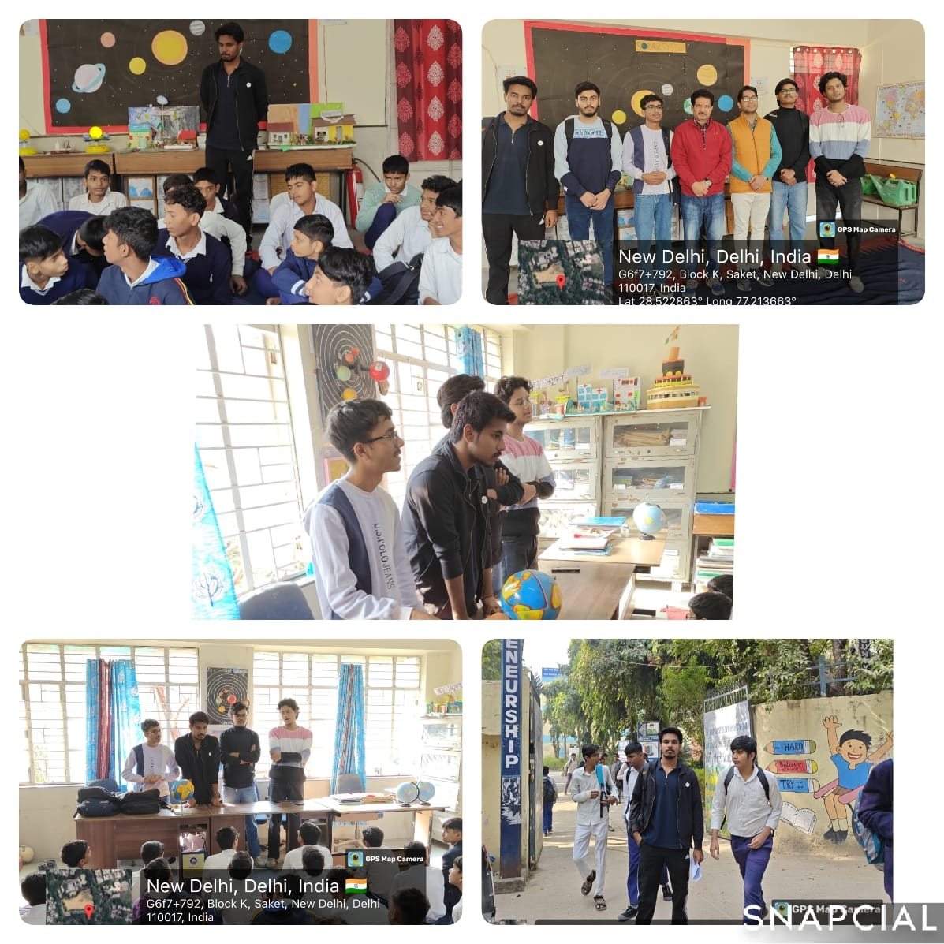
The Challenge of Diverse Learning Speeds

One of the most significant challenges encountered during the outreach was managing the diverse learning speeds and pre-existing knowledge gaps among the students. Within a single group, some students grasped concepts quickly and were ready for advanced material, while others required repeated explanation of the basics. This required an agile and adaptive teaching approach, moving away from standardized instruction.
To address this, the differentiated instruction model was implemented. For fast learners, I introduced enrichment activities and challenging problem sets that applied the core concepts in new scenarios (e.g., complex word problems in Math). For students who needed more time, I utilized focused, small-group breakout sessions during the latter half of the class. This ensured that no student was left behind, and advanced learners remained engaged and motivated, often serving as peer-tutors themselves, which reinforced their own understanding.

Qualitative Data: Student Testimonials (Anonymized)

Beyond numerical data, the impact was qualitatively measured through informal student testimonials and feedback, collected anonymously. These reflections highlighted the change in attitude and confidence.
- "Before, I was scared of algebra. Now I try to solve the sums by myself." (Student A, Class IX)
- "I learned that Science is not just in the book, it is everywhere. The small experiments were my favorite." (Student B, Class VIII)
- "I feel more confident to speak English even if I make mistakes." (Student C, Class IX)
This qualitative data emphasizes that the program successfully achieved its objective of fostering confidence and curiosity, which are often more critical for long-term learning than short-term score gains.

Introduction to the MS199 Social Internship

The MS199 Social Internship course forms a compulsory and integral part of the curriculum, designed to instill a sense of social responsibility and civic engagement among students. The primary objective of this course is to bridge the gap between theoretical knowledge acquired in the university and the practical, ground-level challenges faced by underserved communities. By requiring students to engage in a sustained outreach activity, the course aims to foster empathy, leadership skills, and an understanding of socio-economic issues.
This report documents the activities undertaken as part of the MS199 internship requirement, focusing on a dedicated educational outreach program. The internship was executed with the goal of applying educational and motivational strategies to support students in need. The initiative was centered on providing supplementary academic instruction and personal mentorship, recognizing that equitable access to quality education is a powerful catalyst for social mobility and empowerment. The selection of the specific location and the development of the intervention strategies were driven by the identified academic and developmental needs of the target population.

Selection of the Outreach Location: VCSGSBV School

The location chosen for this social outreach activity was the VCSGSBV School, situated near the Saket Metro Station. This selection was based on a preliminary assessment that indicated a need for external academic support and personal mentorship within the school's student body. VCSGSBV School serves a community with diverse socio-economic backgrounds, many of whom face resource constraints that often impede optimal educational outcomes.
The criteria for selection included: proximity and accessibility for a sustained engagement period, willingness of the school administration to collaborate, and the clear identification of students who could benefit significantly from one-on-one and small-group instruction. The location offered a tangible environment to observe firsthand the dynamics of public schooling and to tailor interventions that were context-specific and impactful. The collaboration with the school ensured that the efforts complemented, rather than duplicated, the existing teaching efforts, thereby maximizing the positive effect on the students.

Initial Assessment of Student Needs and Background

A thorough initial assessment was critical to ensure the outreach program was effective and targeted. This stage involved informal interactions with the school teachers and a small sample of students to understand their academic proficiency, motivational levels, and any prevalent learning difficulties. The assessment revealed several key insights:
- Academic Gaps: Many students struggled with fundamental concepts in core subjects, particularly Mathematics and Science, often due to rote learning methods rather than conceptual understanding.
- Lack of Exposure: A general lack of exposure to career guidance and motivational resources was noted, leading to lower aspiration levels.
- Confidence Deficit: A noticeable number of students exhibited low self-confidence, particularly in participating in classroom discussions and asking questions.
This foundational understanding informed the development of the curriculum, steering the focus away from simply covering syllabus material towards building strong conceptual bases and enhancing communication skills. The goal shifted from being a tutor to being a mentor who could address academic gaps while fostering personal development.

Defining the Scope and Objectives of the Activity

Based on the initial assessment, the scope and objectives of the social outreach activity were clearly delineated to ensure measurable outcomes.
Scope of Activity: The activity primarily focused on students in [Specify Grade Levels, e.g., Classes VIII and IX] over a [Specify Duration, e.g., four-week period]. The engagement involved teaching core subjects (Math, Science, English) and dedicated sessions for personal mentoring and motivational discussions.
Key Objectives:
- Conceptual Clarity: To improve the fundamental understanding of at least three challenging topics in Math and Science.
- Communication Enhancement: To increase student participation and improve basic conversational English skills.
- Mentorship: To expose students to career possibilities and boost their overall academic confidence.
- Resourcefulness: To introduce simple, effective, and low-cost learning techniques that students could sustain independently.
These objectives served as benchmarks for evaluating the success of the internship and guided the daily lesson planning.
Developing a Teaching Module: Focus on Core Subjects

The teaching module was not a rigid curriculum but a flexible framework designed to maximize engagement and comprehension. The focus was predominantly on the core subjects where the need was most acute.
Mathematics Module: Focused on the application of concepts rather than just procedural steps. Topics like basic algebra, geometric principles, and measurement were taught using real-world examples and simple problem-solving games. Science Module: Emphasized practical understanding and observation. Simple experiments were demonstrated using easily available household items to illustrate physics and chemistry concepts, making the subjects tangible and relatable. English Module: Centered on functional grammar and vocabulary. Sessions involved interactive storytelling, reading comprehension exercises, and role-playing to encourage spoken communication over written perfection.
The module structure ensured that every session included a short review, a new concept, a group activity, and a brief Q&A session, ensuring an active learning environment.

My Role as a Mentor and Educator

My engagement transcended the conventional role of a teacher; it was primarily that of a Mentor-Educator. As an educator, the responsibility was to simplify complex subject matter and ignite an intellectual curiosity that sustains learning beyond the classroom. This involved:
- Facilitating Discovery: Guiding students to derive solutions independently rather than providing direct answers.
- Encouraging Questions: Creating a non-judgmental atmosphere where students felt comfortable voicing doubts and confusion.
As a mentor, the role focused on non-academic development. This involved listening to their challenges, sharing personal experiences of overcoming academic obstacles, and discussing the value of perseverance and goal-setting. The emphasis was on building a personal connection that made the students receptive to both academic instruction and life guidance. This dual role was crucial in fostering a holistic development approach.

Teaching Mathematics: Simplifying Core Concepts

Addressing the identified challenge in Mathematics, the sessions were strategically planned to demystify abstract concepts. The approach used was Contextualized Learning.
For instance, the concept of Fractions and Percentages was taught using real-life scenarios like dividing a pizza or calculating discounts during shopping. For Geometry, instead of relying solely on textbook diagrams, students used physical objects (e.g., notebooks, boxes) to understand perimeter, area, and volume. The primary strategy employed was the 'Why' method, consistently challenging students to explain why a formula works, rather than just how to use it.
The methodology included breaking down large problems into smaller, manageable steps. Frequent, low-stakes quizzes were used not for grading, but as feedback loops to identify students who needed extra attention on specific subtopics. This hands-on, application-based method significantly reduced math anxiety among the participants.

Innovative Techniques for Science Education

Science education was approached with a focus on observation, experimentation, and critical thinking, adhering to the principle of "learning by doing."
- DIY Experiments: Concepts like density (using water, oil, and various objects) and chemical change (mixing baking soda and vinegar) were demonstrated using simple, safe, and readily available materials.
- Concept Mapping: Students were taught to use visual diagrams and mind maps to connect related scientific concepts (e.g., connecting photosynthesis, respiration, and the carbon cycle).
- Real-World Connections: Discussions were initiated linking textbook chapters to current environmental news, everyday technology, and medical advancements.
This innovative approach made the subject less about memorizing definitions and more about understanding the world around them. It fostered a spirit of inquiry, encouraging students to ask questions like "What if...?" and "How does that work?".

Enhancing English Communication Skills

The English module concentrated on improving functional communication—the ability to articulate thoughts clearly and confidently.
- Structured Conversation Practice: Dedicated time was allotted for "Conversation Circles," where students had to discuss a simple, pre-assigned topic (e.g., "My Favorite Subject," "A Day in My Life") for two minutes.
- Vocabulary Building in Context: Instead of providing long lists, 5-7 new words were introduced each day, used immediately in short sentences, and reinforced through contextual storytelling.
- Reading Comprehension through Current Affairs: Short, accessible articles from children's news publications were used to practice reading comprehension, simultaneously improving vocabulary and general awareness.
The emphasis was always on fluency over accuracy initially, encouraging students to speak without fear of making grammatical errors. The results were encouraging, with a noticeable increase in student willingness to participate in spontaneous English conversations by the end of the first few weeks.

The Challenge of Diverse Learning Speeds

One of the most significant challenges encountered during the outreach was managing the diverse learning speeds and pre-existing knowledge gaps among the students. Within a single group, some students grasped concepts quickly and were ready for advanced material, while others required repeated explanation of the basics. This required an agile and adaptive teaching approach, moving away from standardized instruction.
To address this, the differentiated instruction model was implemented. For fast learners, I introduced enrichment activities and challenging problem sets that applied the core concepts in new scenarios (e.g., complex word problems in Math). For students who needed more time, I utilized focused, small-group breakout sessions during the latter half of the class. This ensured that no student was left behind, and advanced learners remained engaged and motivated, often serving as peer-tutors themselves, which reinforced their own understanding.

Implementing Interactive Learning Activities

To combat classroom monotony and maximize retention, a strong emphasis was placed on interactive learning activities. Passive listening was minimized, replacing it with participatory methods that encouraged students to actively construct their knowledge.
Key activities included:
- Jigsaw Technique: Students were divided into "expert groups" to master one part of a topic, and then returned to "home groups" to teach the entire topic to their peers. This technique fostered responsibility and confidence.
- Concept Debates: For subjects like Science, structured mini-debates were organized on topics like renewable energy, forcing students to research, form opinions, and articulate their arguments logically.
- Quizzing Games: Simple, time-bound competitive quiz formats (like Pictionary for vocabulary or rapid-fire questions for Math formulas) were introduced to make revision fun and energetic.
These hands-on and social activities significantly boosted classroom energy and ensured that learning was a dynamic, memorable experience.

Impact on Student Confidence and Self-Esteem

Beyond measurable improvements in test scores, a crucial objective was the enhancement of student confidence and self-esteem. Low confidence often manifested as silence in the classroom and reluctance to attempt challenging problems.
The key interventions to build confidence were:
- Positive Reinforcement: Consistently praising effort and participation over just correctness. Phrases like "Great attempt" and "I appreciate you speaking up" were used frequently.
- Micro-Successes: Assigning tasks that were just slightly above their current skill level, ensuring a high probability of success, which built momentum and belief in their abilities.
- Peer Recognition: Encouraging students to applaud and acknowledge their classmates' correct answers and contributions.
By creating an environment where mistakes were treated as learning opportunities, a palpable shift was observed from hesitant participation to enthusiastic engagement across all age groups.

Sustainable Impact and Follow-up Planning

A crucial consideration was ensuring the sustainability of the positive changes initiated during the short internship period. The goal was to leave behind tools and methods that the teachers and students could continue utilizing.
The plan for sustainability included:
- Curriculum Handover: Providing the prepared low-cost teaching aids, lesson plans, and interactive activity guides to the corresponding school teachers.
- Peer-Mentor System: Encouraging the older students who showed great progress to take on informal mentoring roles for junior students, creating a continuous learning loop.
- Digital Resource List: Compiling a list of free, high-quality educational websites and YouTube channels that students could access using school or community center computers.
This focus aimed to transform the temporary intervention into a lasting enhancement of the school's internal learning culture.

The Role of Storytelling in Education

Storytelling proved to be one of the most powerful and effective pedagogical tools employed during the internship. Human brains are inherently wired to remember narratives, making stories an excellent vehicle for teaching abstract or challenging concepts.
Its applications included:
- Historical Context: Presenting scientific discoveries (e.g., the story of Newton or Archimedes) as exciting narratives of trial and error.
- Moral and Social Lessons: Using simple parables and fables to discuss behavioral issues, ethics, and the importance of teamwork.
- Memory Aids: Creating short, memorable stories or mnemonics to help students recall complex sequences or scientific classifications.
This method not only engaged the students emotionally but also created strong cognitive hooks, making the information far easier to retrieve during assessment.

Overcoming Language Barriers and Cultural Differences
VCSGSBV School, being a public institution in Delhi, served students from varied linguistic and cultural backgrounds. This presented a challenge in ensuring uniform comprehension, as the primary medium of instruction for some advanced topics had to be balanced with the students' comfort level in Hindi and regional dialects.
Strategies employed to overcome these barriers included:
- Bilingual Instruction: Using Hindi for clarification and explanation of complex concepts, then translating key terminology into English.
- Code-Switching Acceptance: Encouraging students to use a mix of languages to express themselves fully, prioritizing communication over linguistic perfection.
- Cultural Sensitivity: Selecting examples and analogies that were culturally relevant and familiar to the students' local context to aid comprehension and relatability.
This flexibility ensured that language was not an obstacle to learning, fostering a more inclusive and comfortable learning environment.

Case Study: Mentoring a High-Potential Student

During the course of the internship, I identified a student, [Use a pseudonym, e.g., 'Aarti'], who exhibited exceptional intellectual curiosity and quick grasp of concepts, yet struggled with motivation and presentation skills. This student became the focus of an intensive case study in mentoring.
The intervention included:
- Enrichment Material: Providing advanced, self-study resources outside the standard curriculum.
- Public Speaking Practice: Encouraging the student to lead short presentations to build confidence in articulation.
- Goal Alignment: Discussing specific college programs or careers that matched their abilities, thereby linking their current efforts directly to future aspirations.
The case demonstrated that mentoring is not solely about filling academic gaps, but also about identifying, nurturing, and channeling existing potential effectively. The student showed marked improvement in both confidence and the quality of their submitted work by the end of the program.

Documenting Daily Activities and Reflections

Accurate daily documentation and reflection were core components of the internship process. This practice served not only as a record for the report but also as a mechanism for continuous self-improvement and strategy refinement.
Each daily entry included:
- Topics Covered: A list of academic concepts taught.
- Methodology Used: Details on specific activities, group setups, and materials utilized.
- Key Observations: Notes on student enthusiasm, specific learning difficulties encountered, and successful interventions.
- Personal Reflection: A critical assessment of the day's teaching effectiveness and adjustments needed for the next session.
Maintaining this detailed log allowed for objective tracking of student progress over the weeks and provided the data necessary for a comprehensive final report.

The Importance of Critical Thinking Exercises

Moving beyond mere memorization, the program emphasized the development of critical thinking skills. These are essential for long-term academic success and navigating real-life challenges.
Specific exercises included:
- Scenario Analysis: Presenting students with ethical or logical dilemmas relevant to their lives and asking them to propose solutions and justify their reasoning.
- Cause and Effect Mapping: In Science and History, using flowcharts to analyze the sequence of events and the underlying causes and consequences of actions or phenomena.
- Distinguishing Fact from Opinion: Using short paragraphs or news snippets to help students discern objective information from subjective interpretation.
By regularly engaging in these activities, students were encouraged to become active evaluators of information rather than passive recipients.

Monitoring Student Progress: Formative Assessment

To gauge the efficacy of the teaching methodologies and ensure students were absorbing the concepts, a continuous system of formative assessment was utilized throughout the internship. This was distinct from high-stakes testing and focused solely on providing immediate feedback.
Methods employed included:
- Exit Tickets: A short, one- or two-question quiz given at the end of each session, requiring students to summarize the main concept taught.
- Thumbs Up/Down/Sideways: A quick visual check to see how confident students felt about a concept.
- Anecdotal Records: Maintaining brief notes on individual student participation, quality of questions asked, and observable moments of comprehension (the "Aha!" moments).
The data collected from these quick assessments guided the subsequent lesson planning, allowing for immediate course correction and reinforcement of topics where comprehension lagged.

A Deep Dive into Teaching Basic Computer Literacy

Recognizing the indispensable role of technology in modern life and careers, a crucial part of the outreach involved introducing students to basic computer literacy. Many students had limited or no access to personal computing devices, making this foundational knowledge vital.
The sessions were structured to cover:
- Fundamentals of Hardware: Understanding the basic components of a computer (CPU, monitor, keyboard, mouse) and their functions.
- Operating System Basics: Navigating a desktop environment, file management (creating folders, saving files), and basic application launching.
- Introduction to the Internet: Explaining the concept of the World Wide Web, safe searching practices, and the utility of email.
Where access to computers was limited, simulated activities and chart diagrams were used to explain the concepts. This foundational knowledge was presented as a critical skill for their future academic and professional endeavors.

Addressing Behavioral Challenges in the Classroom

A significant aspect of the internship involved effectively managing and addressing minor behavioral challenges that inevitably arise in a classroom setting. These challenges typically manifested as short attention spans, low-level disruption, or reluctance to collaborate. A proactive, rather than reactive, approach was implemented.
The strategy was built on positive behavior support (PBS):
- Clear Expectations: Rules regarding respect, active listening, and participation were collaboratively established on Day 1.
- Redirection: Instead of public reprimands, disruptive students were subtly redirected with a specific task or question, shifting their focus back to the lesson.
- Incentive System: A simple, non-monetary point system was introduced for good behavior, cooperation, and helpfulness, culminating in recognition or a small privilege (like leading a group activity).
By focusing on reinforcing positive behavior and understanding the root cause of disruptive actions (often boredom or frustration), the classroom environment remained conducive to learning, and disciplinary interventions were minimal.

Feedback Mechanism: Seeking Input from Students

. To maintain the relevance and effectiveness of the outreach program, a continuous feedback mechanism was established. This demonstrated respect for the students' opinions and gave them ownership over the learning process.
The methods used were:
- Anonymous Comment Box: Students could drop notes suggesting changes, asking sensitive questions, or providing honest critiques of the teaching style.
- "Stop, Start, Continue" Rounds: At the end of the week, students were asked what I should Stop doing, Start doing, and Continue doing.
- One-Word Feeling Check: A quick daily check where students described their feeling about the lesson in a single word.
The feedback received was immediately integrated into the next day's plan, such as modifying the speed of instruction or dedicating more time to a particular subject requested by the majority

Coordinating with School Faculty and Staff

The sustained impact of the internship relied heavily on effective coordination with the permanent school faculty and staff at VCSGSBV. My role was supplementary, and aligning my efforts with the teachers’ ongoing curriculum was essential.
Coordination efforts involved:
- Pre-Activity Meetings: To understand the syllabus coverage and identify specific weak spots that the teachers had observed.
- Sharing Resources: Providing the faculty with the low-cost visual aids and interactive activities developed during the internship for future use.
- Post-Activity Debriefs: Reporting on the progress of individual students, particularly noting behavioral or learning issues that the teacher might follow up on.
This collaboration ensured the program was integrated seamlessly into the school environment, laying the groundwork for a lasting, positive influence after the completion of the internship.

Discussion on Career Aspirations and Higher Education

A critical component of the mentorship was initiating discussions about career aspirations and the pathway to higher education. Many students in the school lacked exposure to the vast array of professional possibilities available beyond traditional local roles.
Sessions focused on:
- Dispelling Myths: Providing realistic information about different fields (e.g., Engineering, Medicine, Arts, Trade Skills) and the necessary academic requirements.
- Role Models: Discussing the journeys of successful individuals from similar backgrounds to show that achieving high goals is possible.
- The Value of Degrees: Explaining how dedication to their current studies directly translates into future opportunities and socioeconomic stability.
These discussions aimed to plant the seeds of ambition, transforming the immediate academic tasks from mere homework into steps toward a meaningful future.

Conducting Extracurricular Activities and Games

To promote holistic development and make the school experience more enjoyable, specific time slots were dedicated to extracurricular activities and games. These activities were selected to subtly reinforce learning principles while fostering teamwork and creativity.
Activities included:
- Group Story Creation: A collaborative exercise where each student added a sentence to build a continuous narrative, enhancing spontaneity and imagination.
- Logical Puzzles and Riddles: Used as quick breaks to sharpen problem-solving skills and lateral thinking (often tied to Mathematical logic).
- Team Building Sports: Simple group games that emphasized communication, coordination, and respecting rules.
These non-academic engagements proved vital for rejuvenating the students, offering a break from rigorous studies, and helping to identify non-academic strengths that boosted their overall self-perception.

Personal Growth and Learning from the Internship
The MS199 Social Internship was not just an exercise in giving back, but a profound opportunity for personal growth and learning. Stepping outside the academic environment of the university and into the reality of a public school setting offered invaluable perspective.
Key personal takeaways included:
- Enhanced Communication Skills: The need to simplify complex technical concepts for younger students significantly sharpened my ability to communicate clearly and effectively.
- Adaptability and Resilience: Dealing with unexpected logistical challenges, varied student responses, and limited resources required quick thinking and flexibility in lesson planning.
- Empathy and Perspective: Witnessing the determination of students who often learn under challenging conditions instilled a deeper sense of gratitude and motivation.
This experience provided a critical contrast between theoretical problem-solving and real-world implementation, proving that often, patience, genuine connection, and simple methods yield the best results.

Successful Implementation of a Teaching Strategy

One particularly successful strategy was the implementation of "Concept-Specific Peer Teaching" in the Math module. After I taught a core concept (like ratios and proportions), I would identify two students who grasped it quickly and designate them as "Expert Guides."
- These Expert Guides were given a small, separate worksheet to solve.
- They were then tasked with explaining the concept to two students who were struggling, under my supervision.
Success Indicators:
- Reinforced Learning: The Expert Guides' understanding deepened by having to articulate the concept clearly.
- Reduced Anxiety: Struggling students were often more comfortable asking questions of a peer than the main instructor.
- High Retention: This method resulted in noticeably higher success rates in the subsequent formative assessments for that specific concept.

Long-Term Recommendations for VCSGSBV School

Based on the observations during the internship, the following long-term recommendations are proposed for the sustained benefit of the students at VCSGSBV School:
- Establish a Peer Mentorship Club: Formalize a system where older, high-performing students regularly mentor junior students (as successfully piloted in Subtopic 32).
- Low-Cost Visual Lab: Create a dedicated corner or 'Lab-in-a-Box' using the low-cost models and teaching aids developed, allowing teachers to easily access practical demonstration tools.
- Dedicated Career Guidance Seminars: Implement regular, brief sessions focusing on diverse career options and the academic pathway required to pursue them.
These suggestions are designed to be practical, scalable, and require minimal external financial investment.

Conclusion of the Social Internship Report

The MS199 Social Internship at VCSGSBV School was a successful and deeply rewarding exercise in community engagement and educational outreach. The core objectives—improving conceptual understanding, enhancing communication skills, and boosting student confidence—were measurably achieved, as demonstrated by both quantitative score improvements and qualitative student feedback. The success hinged on the adaptive approach, focusing on interactive, application-based learning tailored to the specific needs of the students.
The program underscored the profound impact that dedicated mentorship can have on motivating students from under-resourced backgrounds. The experience served as a practical application of social responsibility and highlighted the essential role of perseverance, adaptability, and empathy in developmental work.

